Chromium on .NET 是一个建立在Chromium Project基础之上的.NET应用程序开发框架，允许.NET开发者在Chromium基础之上开发.NET应用系统，其基本特征如下：

1. 应用系统从核心基础环节具备完整的Chromium功能，因此应用本身就是一款现代互联网浏览器。应用系统与Chromium浏览器的差异是：第一个窗口是用户自定义的应用窗口，第二个以及后续实例同标准的Chromium浏览器，具体的差异细节请参考google官方文档；
2. 支持完整的.NET Framework，除标准的WinForm、WPF等UI组件之外，应用系统还支持Web Browser做为UI组件，允许Web Browser做为.NET UI组件的子窗口，支持.NET与JavaScript互操作；
3. Web页面支持.NET UI组件，允许开发者用标准DOM与.NET（UI）组件编写面向应用的Web页面，开发者可以在.NET Framework强大的功能基础之上充分结合Web页面固有的优势开发符合互联网特征的应用软件；

Chromium on .NET is a .NET application development framework based on the Chromium Project. It allows .NET developers to develop .NET application systems based on Chromium. Its basic characteristics are as follows:

1. The application system has complete Chromium functions from the core basic links, so the application itself is a modern Internet browser. The difference between the application system and the Chromium browser is: the first window is a user-defined application window, and the second and subsequent examples are the same as the standard Chromium browser. For specific differences, please refer to the official Google documentation;

2. Support the complete .NET Framework. In addition to the standard WinForm, WPF and other UI components, the application system also supports the Web Browser as a UI component, allowing the Web Browser to be a child window of the .NET UI component, supporting .NET and JavaScript. Interoperability

3. Web pages support .NET UI components, allowing developers to write application-oriented Web pages using standard DOM and .NET (UI) components. Developers can fully combine the inherent advantages of Web pages based on the powerful features of the .NET Framework. Develop application software consistent with Internet characteristics;

Chromium on .Net is a .Net application development framework based on chromium project. It allows .Net developers to develop application systems based on chromium. Its basic features are as follows:

1. The core foundation of the application system has full Chromium functions, so the application itself is a modern web browser. The differences between the application system and Chrome browser are as follows: the first window is the user-defined application window, and the second and subsequent instances are the same as the standard Chrome browser. For details of the differences, please refer to the official Google Documents;

2. Support the complete .Net framework. In addition to the standard WinForm, WPF and other UI components, the application also supports the web browser as a UI component, allows the web browser as a child window of the .Net UI component, and supports the interoperability between .Net and JavaScript;

3. Web pages support .Net UI components, allowing developers to write application-oriented web pages with standard DOM and .Net (UI) components. Based on the powerful features of the .NET Framework, developers can fully combine the inherent advantages of web pages to develop application software that conforms to the characteristics of the Internet;

Chrome on .NET

Chromium on DotNet is a .Net Application Development Framework based on chromium project. It allows .Net developers to develop Application Systems based on chromium. Its basic features are as follows:

1. By default, the application system has full Chromium functions, so the application itself is a modern Web Browser. For the differences between the application system and the standard chrome, see the official Google Documents;

2. The differences between the application system and Chromium browser are as follows: the first window is the user-defined application window, and the second and subsequent instances are the same as the standard Chromium Browser;

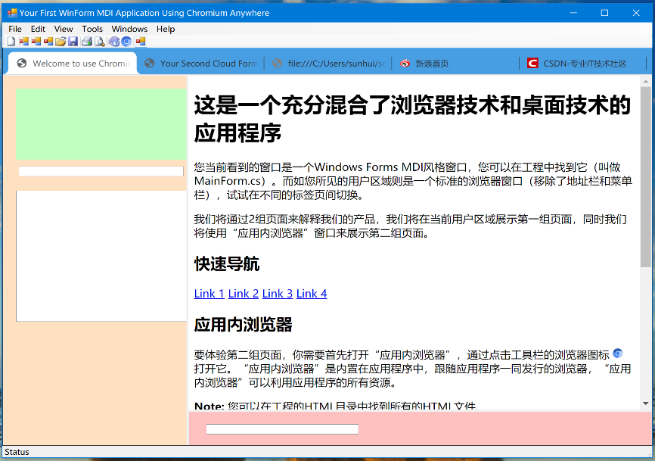

(应用程序的第一个实例窗口是用户自定义的应用窗口)

3. In addition to the standard WinForm, WPF and other UI components, the application system also supports the browser window as a UI component and allows the browser as a sub window of the. Net UI component;

4. The application system allows developers to develop and extend HTML pages with standard DOM and .Net (UI) components

（Extended Web Page in .Net Application）

5. Support. Net and JavaScript interoperability

(. Net and JavaScript interoperability)